Pokhara University

Level: Bachelor | Semester – Spring | Year : 2007
Programme: BE |  | Full Marks: 100
Course: Engineering Mathematics II |  | Time : 3hrs.

Candidates are required to give their answers in their own words as far as practicable.
The figures in the margin indicate full marks.

Attempt all the questions.

 | - Find the shortest distance between the lines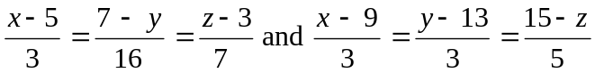. Find out the equation of the line of shortest distance.  - Find the equation to the tangent planes to the sphere 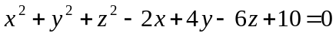 which pass through 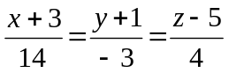.  OR  Obtain the equation of tangent plane at 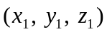of the sphere . | 7  8
 | - State and prove Euler's theorem for a homogeneous function of degree n in x and y, and verify it for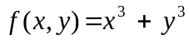.  - Find the minimum value of 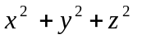such that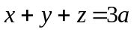. | 8  7
 | - Sketch the region of integration and evaluate the following integral by changing the order of integration: 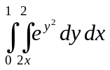.  - Find the volume of the solid whose base is the region in xy-plane that is bounded by the parabola 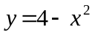and the line 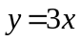 while the top of the solid is bounded by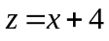.  OR  Find the area between 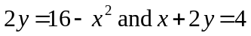 by using double integral. | 7  8
 | a) Solve: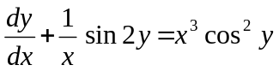.  b) Using method of variation of parameters find the general solution of the equation: 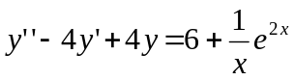 . | 7  8
 | - Solve the following equation by power series method 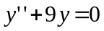.  OR  Define Bessel function of first kind of order n, show that: 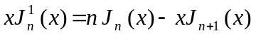.  b) Solve the following initial value problem. | 7  8
 | - Define Laplace transform. Find 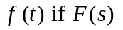is  i) 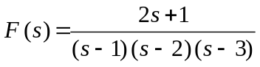 and  ii) Find 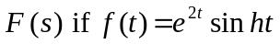  b) Solve using Laplace transformation. | 8  7
 | Attempt all the questions:  - Find the angle between following pair of planes  - Solve: 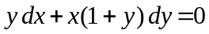  - Find the general solution of 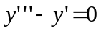  - Find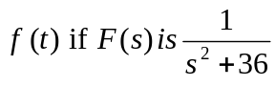  - Given if 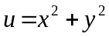verify 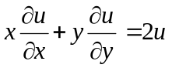 | 5×2

